**FRC 2019 Software and Firmware Setup**

(last updated Feb 09, 2019)

**Current Versions:**

Java 11.0.2

Gradle 5.0

National Instruments FRCUpdate 2019.2.0

Driver Station 19.0

RoboRio 2019_V14

WPILib 2019.4.1

VSCode 1.30.1

Talon SRX Firmware 4.11

PDP 1.4

PCM 1.65

Radio 19.1.1

NavX 3.1.347

Limelight 2019.5.1

**INSTALLING DEVELOPMENT SOFTWARE AND DRIVER STATION**

**Uninstall:** (if you have old versions installed)

National Instruments Software (from Apps & features) – select ‘Remove All’

Gradle 4.9 (just delete folder – probably at c:\program files\gradle 4.9)

VSCode (install VSCode via the WPILibeInstaller to get FRC templates – uninstall from Apps & features)

Intellij (if you have an older version)

Java (older version of Java such as JDK-8)

CTRE

FRC Radio

navX

**Install:**

Git

TortoiseGit (optional)

Intellij

Java

Gradle

WPILib (WPILib and VSCode)

FRCUpdateSuite (Driver station - optional)

CTRE.Phoenix.Framework (Lifeboat for updating Talon firmware - optional)

FRC_Radio_Configuration (to update radio firmware and configure radio - optional)

navX

Limelight (update limelight image – optional)

**Detail Notes:**

**GIT**

- Git-x.x.x-64-bit

- download installer from: [www.git.scm.com/downloads](http://www.git.scm.com/downloads)

- double click exe

- accept defaults

**TortoiseGit**

- TortoiseGit-x.x.x.x-64bit

- download installer from: [www.tortoisegit.org/download](http://www.tortoisegit.org/download)

- accept defaults

**Intellij**

- ideaIC-201x.x.x

- download installer from: [www.jetbrains.com/idea/download](http://www.jetbrains.com/idea/download)

- use community edition

- check 64bit installer, add Open folder in Project, java

- configure at you like accepting defaults

- when opening a project, check ‘Use auto imports’ and ‘Create directories for …’

- set Gradle Home to c:\program files\gradle-5.0-all\gadle-5.0

- set Gradle JVM to ‘Use project JDK (11, …)

- gradle should compile

- allow firewall access

**Java**

**-** jdk-xx.x.x_windows-x64_bin

- download installer from: <https://www.oracle.com/technetwork/java/javase/downloads/jdk11-downloads-5066655.html>

- accept defaults

**Gradle**

- Gradle-x.x-all

- download folder from: [www.gradle.org/install](http://www.gradle.org/install)

- click Install Manually

- click download

- complete v5.0 complete

- copy gradle-5.0-all folder into c:\program files\

**FRC Update Suite** (National Instruments - driver station)

- FRCUpdateSuite_201x.x.x.zip

- make sure your PC has a connection to the Internet as the software will need to activate the license

- download zip from: <http://www.ni.com/download/first-robotics-software-2017/7904/en/>

- double click setup.exe

- accept defaults

- enter you name and team1619 for the organization

- enter B04P63221 for the serial number

- accept license agreements

- run license manager to active the products

- log into your account. If you don’t have one, just set one up.

- click [Activate]

- restart computer

Serial Number: B04P63221

Product: Vision Runtime

Version: 18.0

Activation Code: MYMN-PXBH-BQ2X-PR6B-9CZL

Computer ID: 8223-GFGD-2XNX-BQMD

**WPILib and VSCode**

- WPILibInstaller_Windows64-2019.x.x.zip

- download zip from <https://github.com/wpilibsuite/allwpilib/releases>

- double click exe

- click [All Users]

- click [Select/Download VS Code]

- click [Download]

- uncheck C++ Compiler

- make sure Visual Studio Code, Gradle, and Java JDK/JRE are checked

- leave Tools and Utilities, WPILib Dependencies, and Visual Studio Code Extensions checked

- click [Execute Install]

**CTRE** (talons)

- CTRE.Phoenix.Framework.vx.xx.x.x

- download zip from: <http://www.ctr-electronics.com/hro.html#product_tabs_technical_resources>

- instructions at https://phoenix-documentation.readthedocs.io/en/latest/ch05_PrepWorkstation.html

- double click CTRE.Phoenix.Framework.vx.xx.x.x.exe

- accept defaults

- click [install] with [] trust… checked

**Radio**

- FRC_Radio_Configuration_xx_x_x

- download installer from: <https://wpilib.screenstepslive.com/s/currentCS/m/getting_started/l/144986-programming-your-radio>

- double click FRC_Radio_Configuration_xx_x_x.exe

- accept defaults

- allow WinPCap to be installed

- accept defaults

**navX**

- navX x.x.xxx

- download <https://www.kauailabs.com/public_files/navx-mxp/navx-mxp.zip>

- run setup.exe

- this will install the naxXUI, navXFirmwareUpdater, navXConfig, and navXMagCalibrator

- to update the firmware, you might need to replace the ST files

**Updating** **Limelight Firmware:**

- Instructions at http://docs.limelightvision.io/en/latest/getting_started.html#imaging

- Download Bonjour, USB drivers, New Flash Tool for 2019 and image at:

<https://limelightvision.io/pages/downloads>

**UPGRADING ROBOT FIRMWARE:**

**Roborio:**

Run - roboRIO Imaging Tool.exe

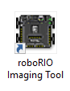

Set up as shown below and click [Reformat]

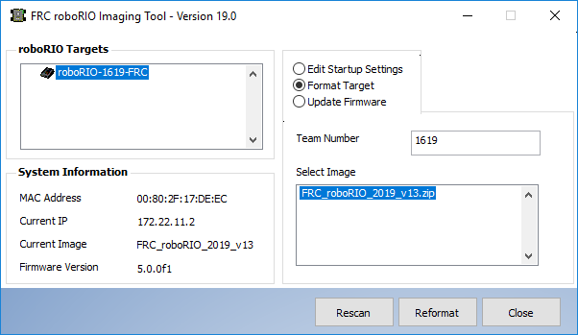

**Talons, PDP, and PWM:**

Connect USB cable from PC to RoboRio

Run - Phoenix Tuner.exe

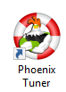

Click [Install Phoenix Library/Diagnostics]

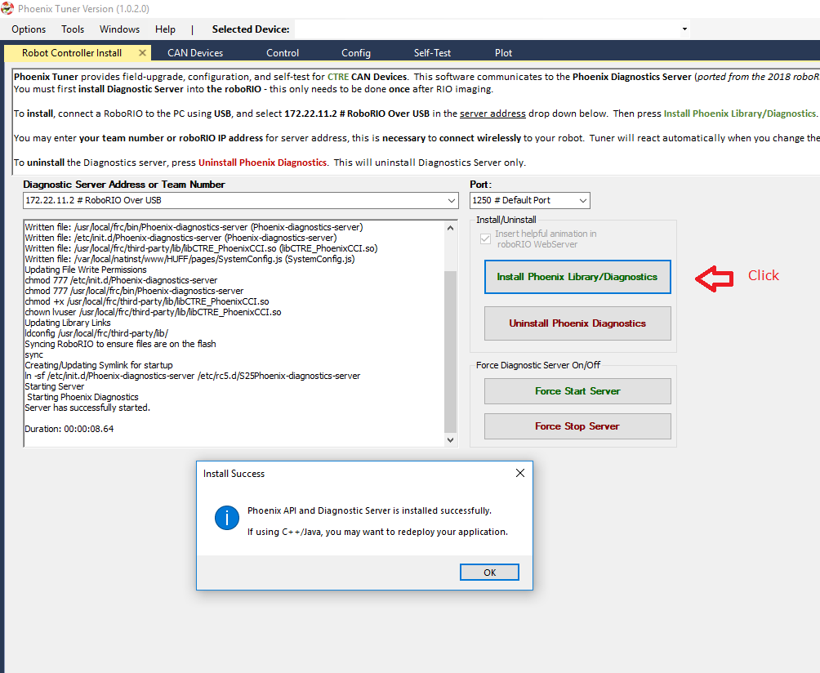

Click the [CAN Devices] tab

Select Talon

Change ID and click [Change ID)

Select device, select firmware file, and click [Update Devices]

(you can update all Talons at once by checking [] “Update all Talon SRX devices”)

Talon = TalonSrx-Application-4.11-season2019.crf

PDP = PDP-Application-1.40.crf

PWM = PCM-Application-1.65.crf

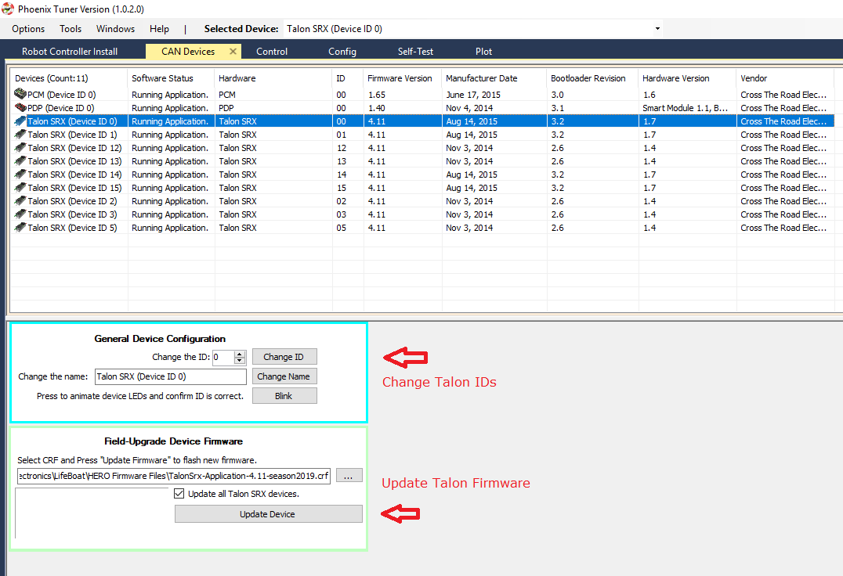

**Radio:**

Disable Wifi adapters and extra LAN adapters so you only have one Ethernet adapter enabled

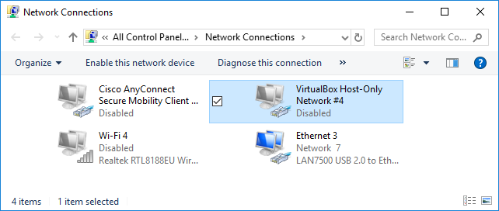

Connect Ethernet cable from PC to Radio

Power Radio either with a separate adapter or by turning on the robot

Run - FRC Radio Configuration Utility.exe

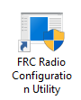

Select the single LAN connection that is connecting the Radio to the PC

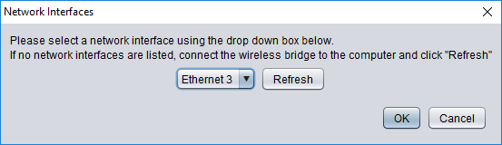

Enter the Team Number

Enter the Robot Name

Click [Load Firmware]

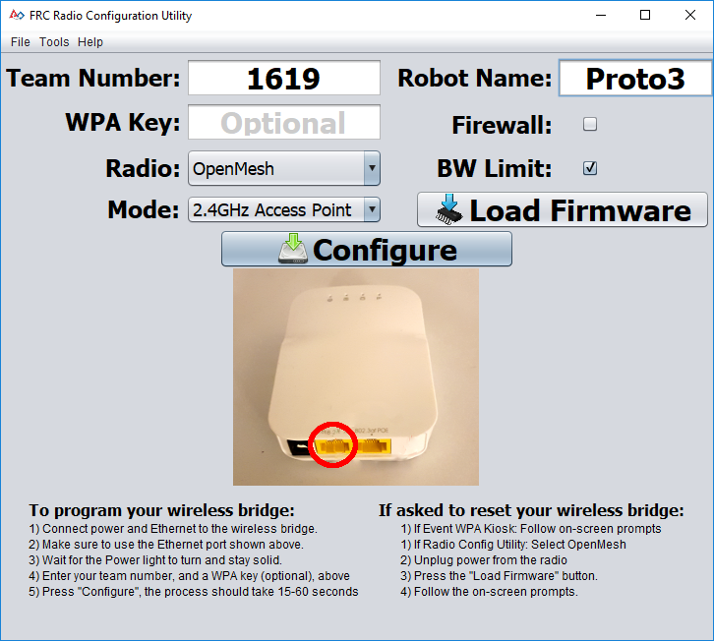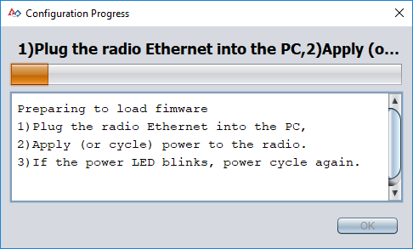

Unplug power from Radio and plug it back in to power cycle the radio.

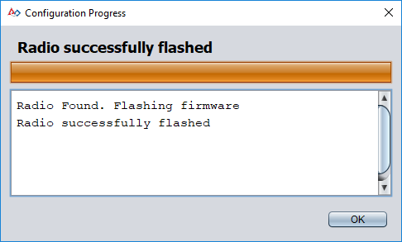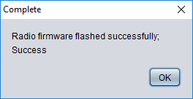

Click [Configure]

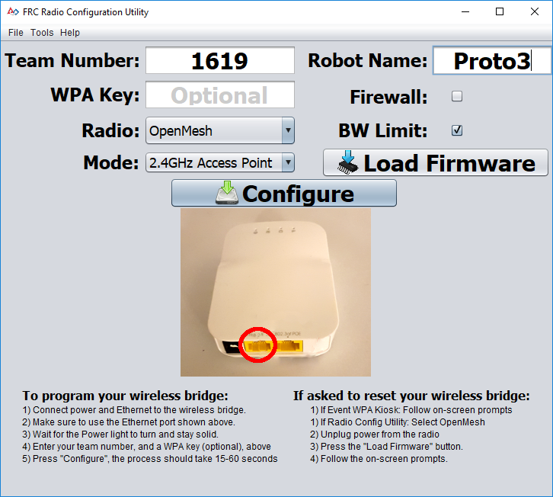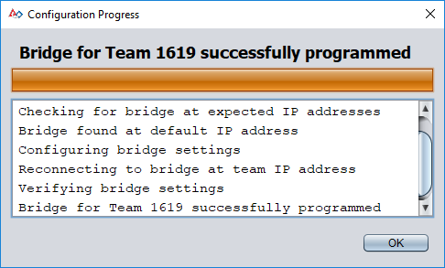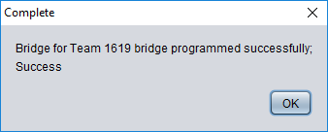

**navXUI:**

– This is a UI that shows the values read from the navX

- Connect navX to PC via USB cable

- Run navXUI

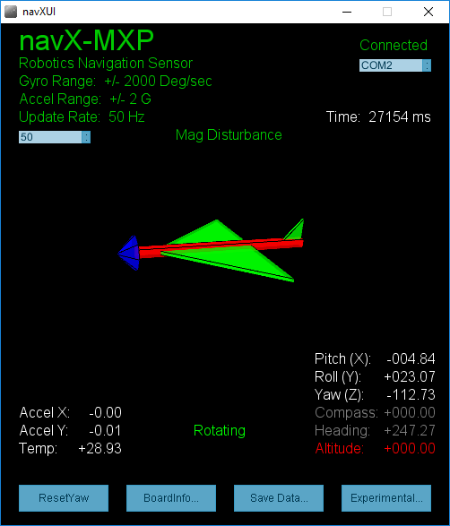

If you are not connecting to the navX, check the USB driver

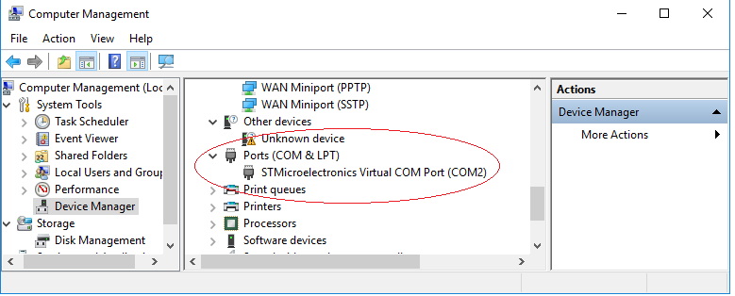

If you do not see the navX as a COM Port, try running VCP_V1.5.0_Setup_W8_x64_64bits.

**navX Calibrating**

- The navX needs to be calibrated when placed into a new orientation

- Place board in the desired orientation

- Power up navX,

- Hold down Cal button on the board for 5 seconds

- Let go of the button

- The red light in front of button should blink on and then off

- Press and release the reset button on the board

- The two green lights should blink off and then on

**navX Firmware Updater:**

- Run navXFirmwareUpdater

- Connect the navX to the PC with a USB cable

- Click the [Currently-loaded …] tab to see the current firmware version

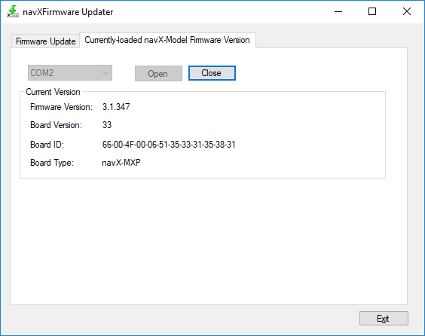

- Click the [Firmware Update]

- Click [Select navX-Model Firmware to load]

- Select C:\Users\username\navx-mxp\firmware\navx-mxp_3.1.347.hex

- Unplug navX from USB cable

- Hold down the cal button on the navX board while plugging it back into the USB cable

- Release Cal button

- Click [Update navX-Model Firmware]

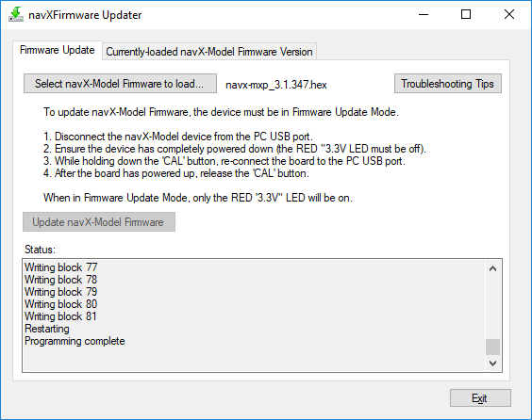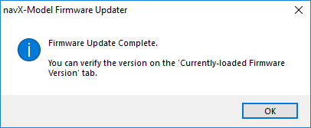

**Updating** **Limelight Firmware:**

- Instructions at http://docs.limelightvision.io/en/latest/getting_started.html#imaging

- Download Bonjour, USB drivers, New Flash Tool for 2019 and image at:

<https://limelightvision.io/pages/downloads>

- Install Bonjour if needed

- Install USB drivers

- Do not use a Windows 7 machine.

- Remove power from your limelight.

- Unplug any secondary camera from the Limelight USB port. (flash tool will not see drive otherwise)

- Run a USB-MicroUSB cable from your laptop to your limelight.

- Apply power to your limelight.

- Run “Balena Etcher”.(balenaEtcher-Portable-1.4.8-x64.exe)

- It may take up to 20 seconds for your machine to recognize the camera.

- Select the latest .zip image in your downloads folder

- Select a “Compute Module” device in the “Drives” menu

- Click “Flash”

- Once flashing is complete, remove power from your limelight

USB Drivers:

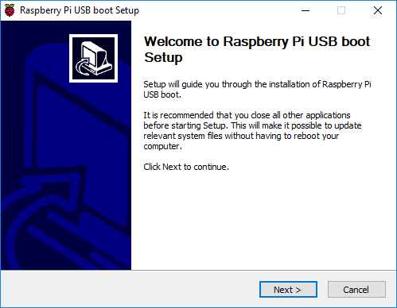

Flash image:

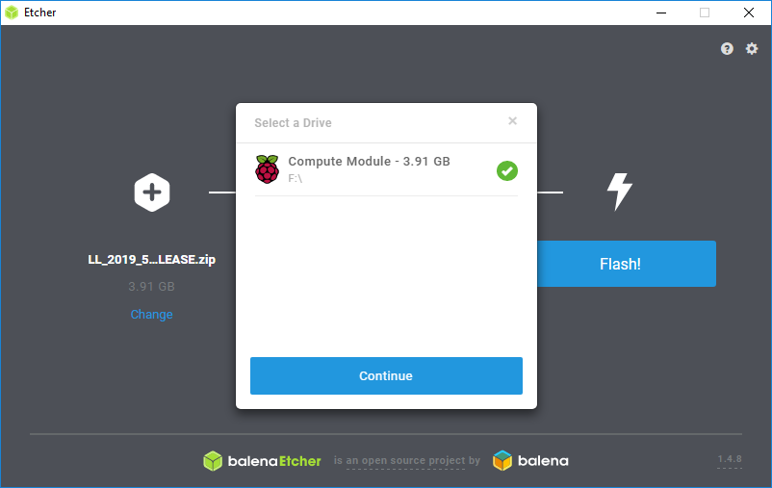

Logger

Disable: log4j2.xml -> comment out

*<AppenderRef ref="AsyncFileLogger" level="ALL"/>*

Get/Delete files on RoboRio (no password)

